**Machine Learning:Module1**

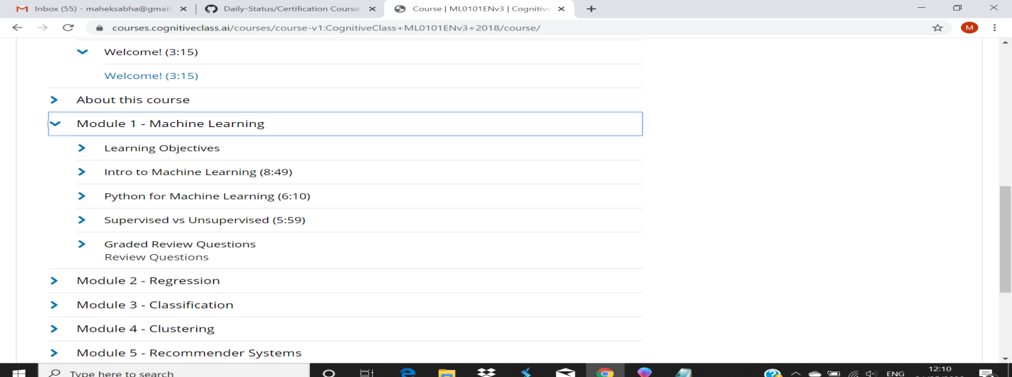

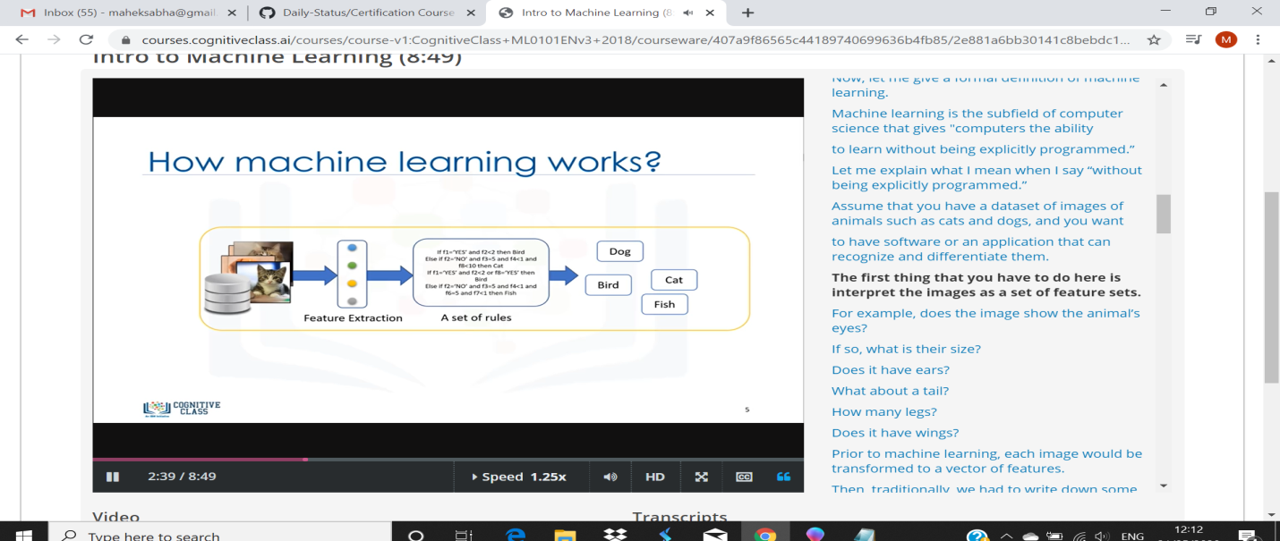

This Machine Learning with Python course dives into the basics of machine learning using an approachable, and well-known, programming language. You'll learn about Supervised vs Unsupervised Learning, look into how Statistical Modeling relates to Machine Learning, and do a comparison of each. Look at real-life examples of Machine learning and how it affects society